**HOW TO UPGRADE FIRMWARE**

**This document tell you how to upgrade Proximity Project motherboard firmware.**

**STEP 1.**

Before start remove all cables from motherboard. Plug USB Type B Micro cable to motherboard.

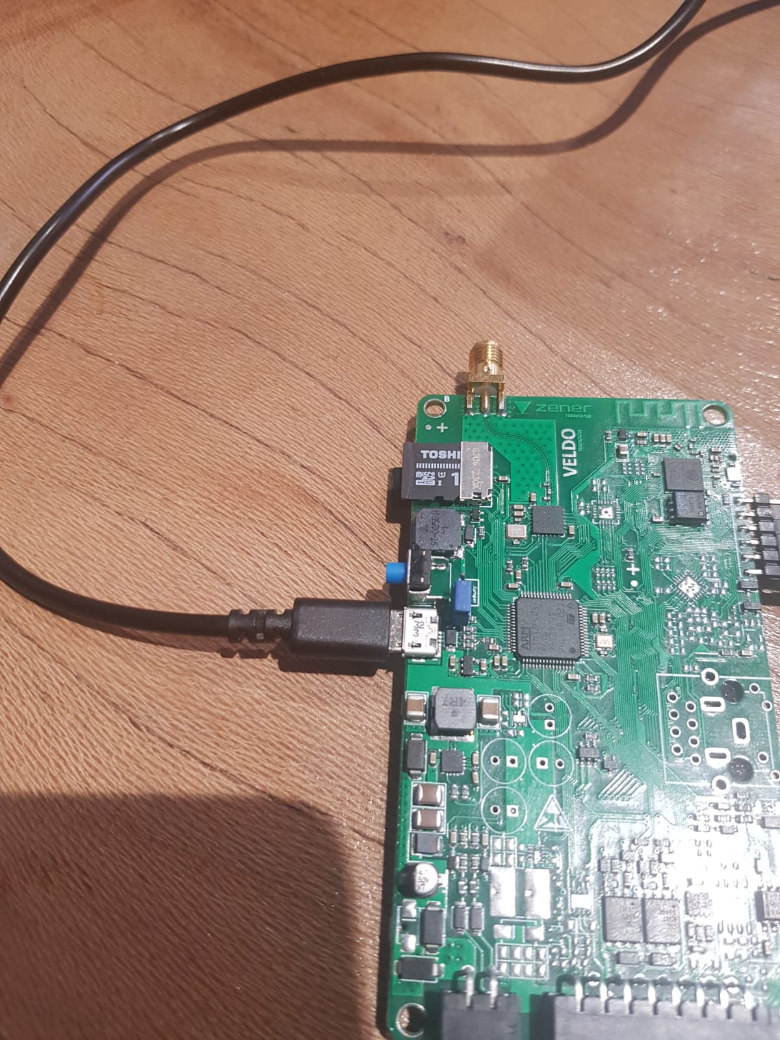

**STEP 2.**

After you plug in other side of the USB cable to your personal computer, you will see popup a window.

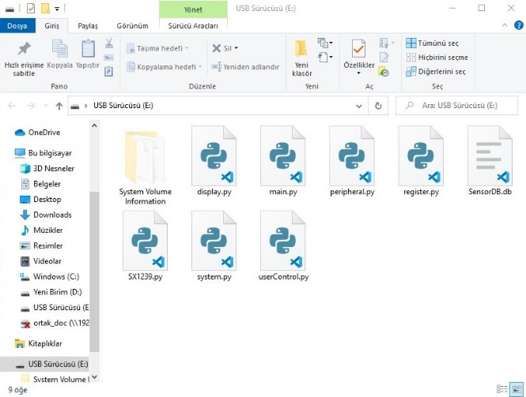

**STEP 3.**

Open the file which is we send you already and copy paste all files into folder.

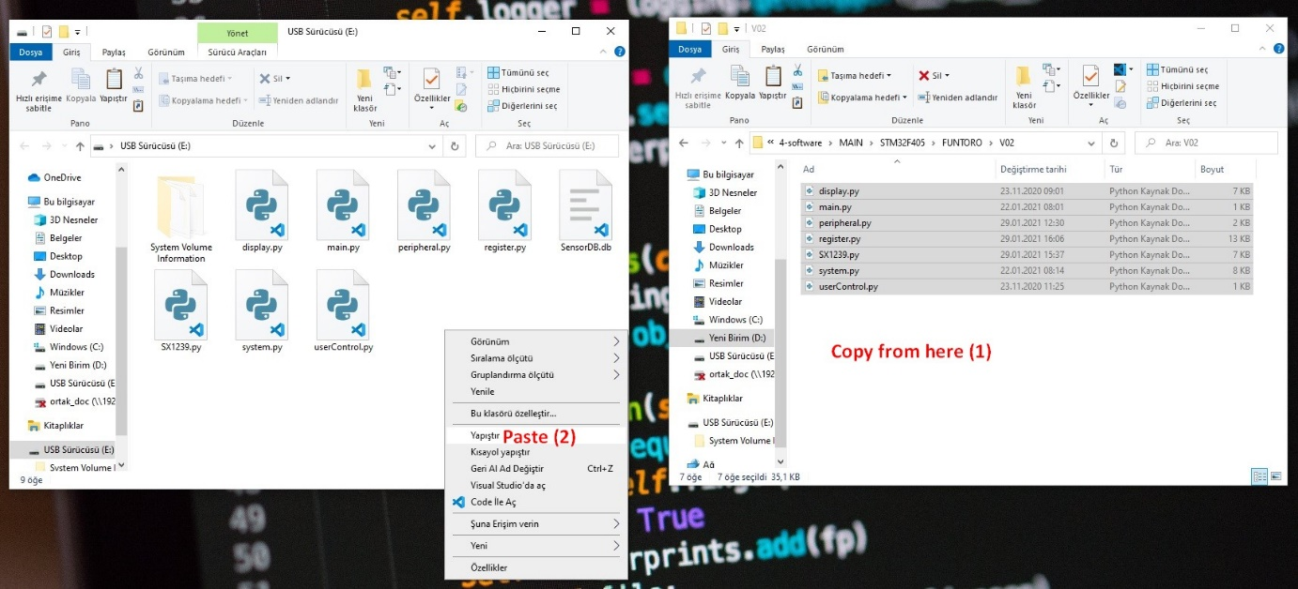

Please select to “Replace all files” option.

**STEP 4.**

Remove all power sources and USB cable from motherboard and plug main power source cable again.